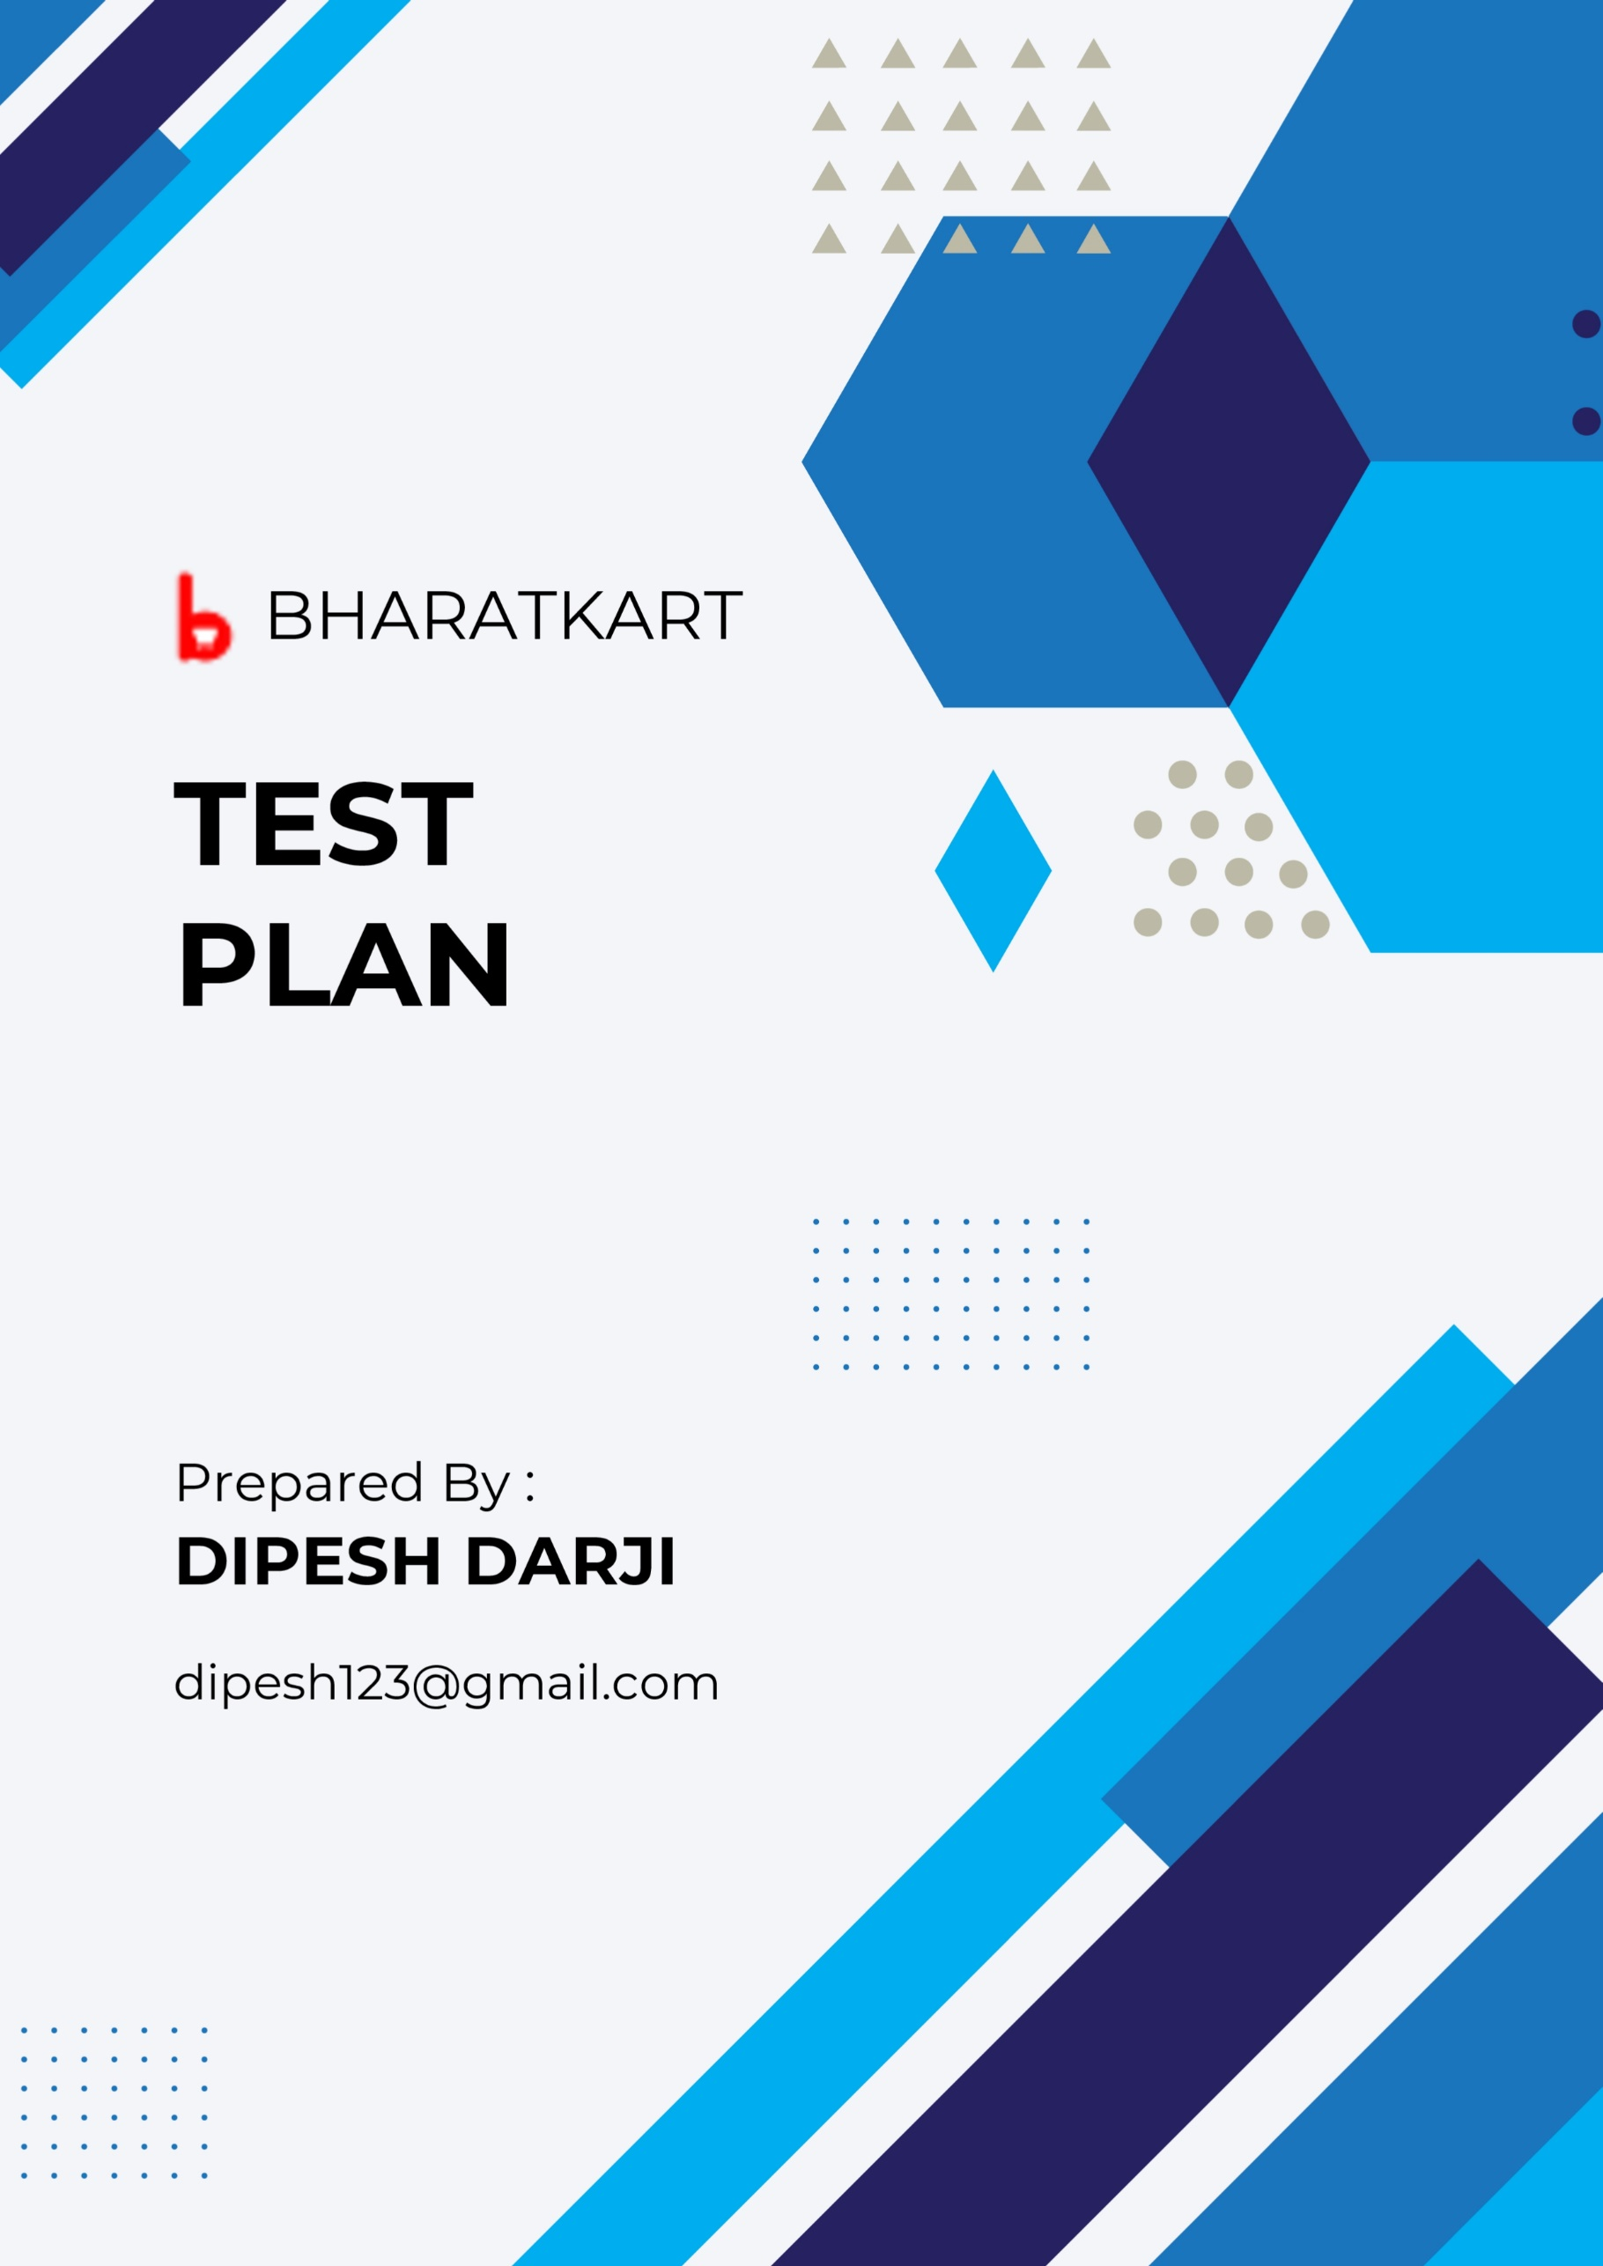

**Table of content**

1. Test Plane Identifier (ID)……………………………………………………………..
2. Introduction………………………………………………………………………………..
3. Reference……………………………………………………………………………………
4. Test Items……………………………………………………………………………………
5. Features to be tested…………………………………………………………………..
6. Features not to be tested…………………………………………………………….
7. Test Environment/Test bed………………………………………………………….
8. Test deliverables…………………………………………………………………………..
9. Test Approach………………………………………………………………………………
10. Suspend & Resume Criteria…………………………………………………………..
11. Entry & Exit Criteria……………………………………………………………………….
12. Risk & Contingencies………………………………………………………………………
13. Roles & Responsibilities…………………………………………………………………..
14. Schedule………………………………………………………………………………………….
15. Staffing and Training………………………………………………………………………..
16. Approvals………………………………………………………………………………………...

**Test Plan for BharatKart**

1. **Test Plan Identifier (ID):**

Bharatkart 1.0 MTP 1.0.1

1. **Introduction:**

Welcome to Bharatkart, your trusted partner in the world of B2B e-commerce. We are a dynamic and forward-thinking company dedicated to simplifying and optimizing the way businesses source and procure goods across all categories. Our commitment to excellence and our unwavering vision and mission drive us every day.

1. **References:**

Software Web Application

1. **Test Items:**
   1. Login
   2. Search Functionality (Product Search)
   3. Cart
   4. Checkout
   5. Payment
   6. Get Support
   7. Post your Requirements
   8. Profile
   9. Wishlist
   10. Add Address
2. **Features to be tested:**
   1. **Login:**

It allows user to register/login in the website to use it.

* 1. **Search Functionality (Product Search):**

Allows user to search any specific product or item.

* 1. **Cart:**

Allows user to see the product’s added into cart.

* 1. **Checkout:**

Process for placing the order for the products.

* 1. **Payment:**

Gateway for making payment of the product.

* 1. **Get Support:**

It allows user to contact with website owner for any help and queries.

* 1. **Post your Requirement:**

If any product is not available on the website or out-of-stock, then user can create a requirement for requesting them to make it available.

* 1. **Profile:**

It allows user to edit profile details like name, email, mobile no, etc.

* 1. **Wishlist:**

It’s a list of products which the user wants to buy in future or desire to buy it.

* 1. **Add Address:**

It allow user to add address for receiving the orders.

1. **Features not to be tested:**
   1. Privacy Policy
   2. Terms of use
   3. FAQs
2. **Test Environment/Test bed:**

|  |  |
| --- | --- |
| RAM | 2Gb to 8GB |
| Processor | I3,I5,I7 |
| Server | Apache Tomcat |
| Browser | Google Chrome, Mozilla, Firefox, Brave. |
| PDF Reader | Adobe Reader |
| Operating System | Windows, Linux |
| Defect Tracking Tool | JIRA |
| Test Management Tool | Zephyer |

1. **Test deliverables:**
   1. Test Plan Document.
   2. Test Scenario Document.
   3. Test Case Document.
   4. Defect Log Report.
2. **Test Approach:**
   1. **Level:** Validation/System Testing.
   2. **Method:** Black Box Testing.
   3. **Type:** Manual Testing.
3. **Suspend & Resume criteria:**

|  |  |
| --- | --- |
| Suspend Criteria | Resume Criteria |
| ShowStopper Found | ShowStopper Fixed |
| Electricity Disconnected | Electricity Resumed |
| Network Crashed | Network Resumed |
| System Crashed | System Repaired |

1. **Entry & Exit Criteria:**
   1. **Entry Criteria:**
      1. Build should be received in time.
   2. **Exit Criteria:**
      1. All the test case should be properly executed.
      2. At-least 95% to 99% of software should be defect less.
      3. Required quality of software should be archived.
2. **Risk & Contingencies:**

|  |  |
| --- | --- |
| Risks | Contingencies |
| Build did not receive in time | Build received in time |
| No proper training provided to tester | Proper training provided to tester |
| Non-availability of testing tools & technology | Availability of testing tools & technology |
| Electricity disconnected | Electricity resumed |
| Manager have no proper co-ordination with team | Manager have proper co-ordination with team |

1. **Roles and responsibilities:**

|  |  |  |
| --- | --- | --- |
| Sr. No | Name of Tester | Tasks |
| 1 | Mr. Dipesh Darji | 1. Test Plan Writing 2. Test Scenario Writing 3. Test Case Writing 4. Test case Execution 5. Defect Log Report Writing |

1. **Schedule:**

|  |  |  |  |
| --- | --- | --- | --- |
| Sr. No | Tasks | Dates | No. of Days |
| 1 | Test Plan Writing | 13/06/2025 | 1 |
| 2 | Test Scenario Writing | 14/06/2025  to  20/06/2025 | 7 |
| 3 | Test Case Writing | 21/06/2025  To  27/06/2025 | 7 |
| 4 | Test Case Execution | 28/06/2025 | 1 |
| 5 | Defect Log Report Writing | 29/06/2025 | 1 |

1. **Staffing and Training needs:**

|  |  |  |  |
| --- | --- | --- | --- |
| Sr. No | Name of Test Executive | Name of Test Lead | Training Topic |
| 1 | Mr. Dipesh Darji | Mr. Amit Jha | 1. Test Plan Writing 2. Test Scenario Writing 3. Test Case Writing 4. Defect Log Report Writing |

1. **Approvals:**

|  |  |  |  |  |
| --- | --- | --- | --- | --- |
| Sr. No | Name of Test Executive | Name of Test Lead | Name of Manager | Remark |
| 1 | Mr. Dipesh Darji | Mr. Amit Jha | Ms. Puja Darji |  |